Project 1. Scanner

2016025823

JUNG JAE, LEE

1. Compilation method and environment

* Edit - MaxOS, VisualStudio Code
* Run – Virtual Box, Ubuntu 16.04LTS
* Manage – Github(in progress), Gitlab(done)

1. Explanation about how to implement and how to operate.

* Globals.h, main.c, util.c - Same as manual implementation.
* Implementation of C Scanner using C code(scan.c)

1. 텍스트이(가) 표시된 사진

   자동 생성된 설명static int ungetNextchar() – update reserved word list like global.h

1. TokenType getToken(void) – I Draw the DFA. First picture is DFA, with out Error, COMMENT, COMMENT_ . second is detail DFA COMMENT, COMMENT_ for cover /* */. There will be case like “/* ***** */”, so when c is * in COMMENT_ STATE, It should stay the state.

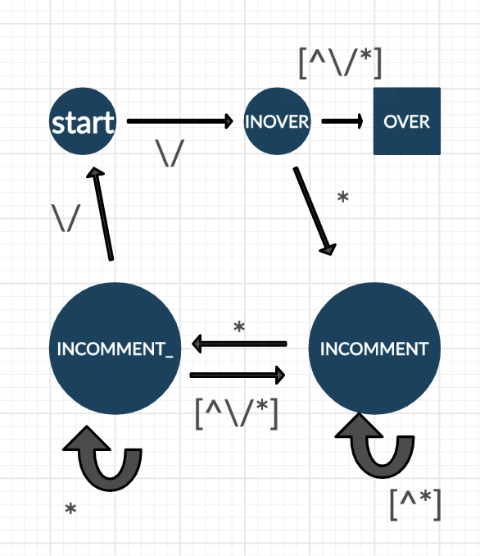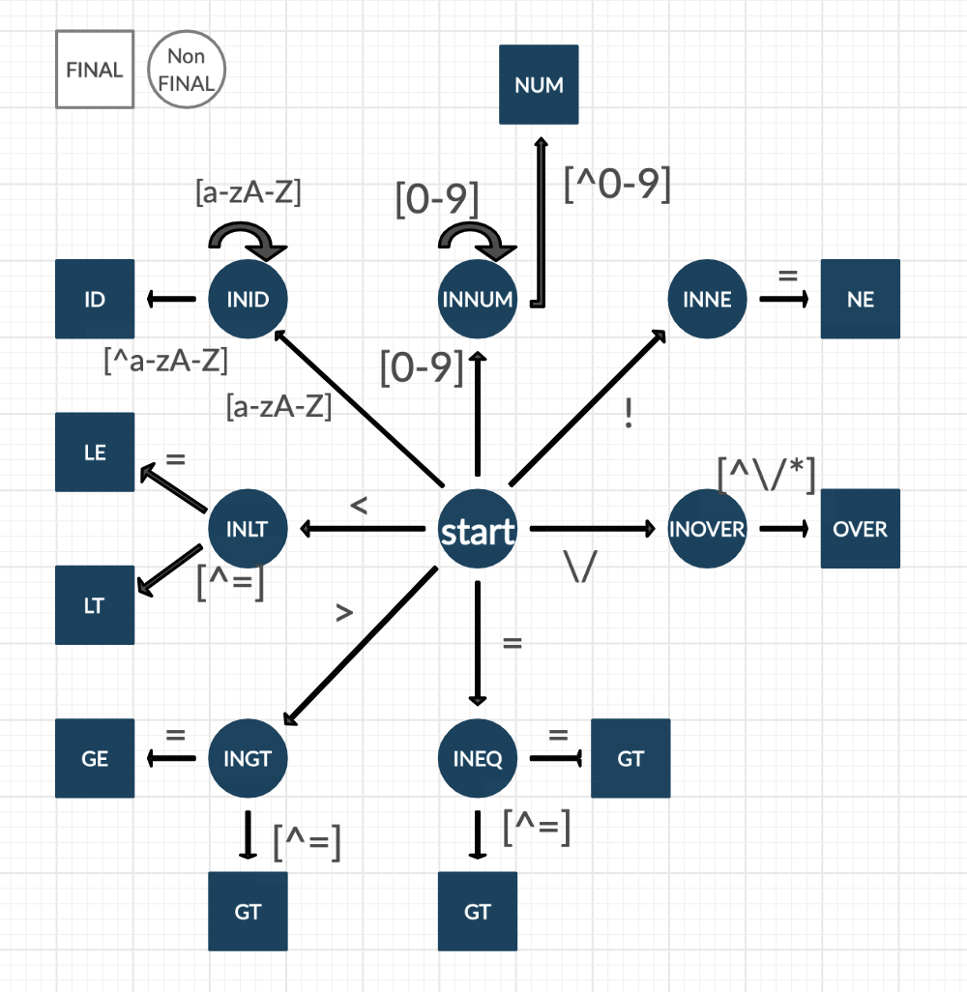

그림 2. COMMENT, COMMENT_

그림 1. DFA without COMMENT, COMMENT_

* 텍스트이(가) 표시된 사진

  자동 생성된 설명lex(flex) - cminus.l – I add some rule at rules section. For cover /* */ comment, I used flag. By using flag, it will check comment is done or not.

1. Example and Result Screenshot
2. 텍스트이(가) 표시된 사진

   자동 생성된 설명cimpl_test.1.txt
3. 텍스트이(가) 표시된 사진

   자동 생성된 설명cimpl_test.2.txt
4. 텍스트이(가) 표시된 사진

   자동 생성된 설명flex_test.1.txt
5. 텍스트이(가) 표시된 사진

   자동 생성된 설명flex_test.2.txt